**Fitness tracker using posture correction integrated with voice assistant.**

Submitted in partial fulfillment of the requirements

of the degree of

Bachelor of Engineering

in

Computer Engineering

by

*Dhruv Suvarna 119A1021*

*Esha Bawaskar 119A1022*

*Ishaa Abdul 119A1025*

Under the Guidance of:

*Prof. Ujwala Ravale*



Department of Computer Engineering

SIES Graduate School of Technology

2022-2023

**CERTIFICATE**

This is to certify that the project entitled **“*Fitness Tracker using posture correction integrated with voice assistant*”** is a bonafide work of the following students, submitted to the University of Mumbai in partial fulfillment of the requirement for the award of the degree of **Bachelor of Engineering** in **Computer Engineering.**

***Dhruv Suvarna 119A1021***

***Esha Bawaskar 119A1022***

***Ishaa Abdul 119A1025***

Prof.Ujwala Ravale Dr.Aparna Bannore Dr.Atul Kemkar

Internal Guide Head of Department Principal

**PROJECT REPORT APPROVAL**

This project report entitled ***Fitness Tracker using posture correction integrated with voice assistant*** by following students is approved for the degree of ***Bachelor of Engineering*** in ***Computer Engineering***

***Dhruv Suvarna 119A1021***

***Esha Bawaskar 119A1022***

***Ishaa Abdul 119A1025***

**Name of External Examiner: --------------------------------**

**Signature:--------------------------------**

**Name of Internal Examiner: --------------------------------**

**Signature:--------------------------------**

**Date:**

**Place:**

**DECLARATION**

I declare that this written submission represents my ideas in my own words and where others’ ideas or words have been included, I have adequately cited and referenced the original sources. I also declare that I have adhered to all principles of academic honesty and integrity and have not misrepresented or fabricated or falsified any idea/data/fact/source in my submission. I understand that any violation of the above will be cause for disciplinary action by the Institute and can also evoke penal action from the sources which have thus not been properly cited or from whom proper permission has not been taken when needed.

Dhruv Suvarna 119A1021 _____________

Esha Bawaskar 119A1022 _____________

Ishaa Abdul 119A1025 _____________

Signature

Date:

**ACKNOWLEDGEMENT**

We wish to express our deep sense of gratitude and thank our Internal Guide, Prof. Ujwala Ravale for her guidance, help and useful suggestions, which helped in completing our project work in time. We are also extremely grateful to our Project coordinator Prof. Prachi Shahane for her guidance provided whenever required. We also thank our Hod Dr. Aparna Bannore for her support in completing the project. We also thank our Principal Dr. Atul Kemkar, for extending his support to carry out this project.

Also we would like to thank the entire faculty of Computers department for their valuable ideas and timely assistance in this project, last but not the least, we would like to thank our teaching and non teaching staff members of our college for their support, in facilitating timely completion of this project.

**Project Team**

Dhruv Suvarna

Esha Bawaskar

Ishaa Abdul

**ABSTRACT**

Health consciousness is increasing day by day amongst youth and elders. Many benefits such as physical, mental and spiritual benefits can be obtained by exercising. The internet is now home to a huge selection of training videos. With the abundance of workout videos available on the internet and with popular fitness tracking apps which are freely available on the internet providing a dedicated workout programs section, more people are following these workouts independently.

The goal is to assist people perform these workouts independently on their own. One typical finding is that it can be challenging for even frequent gym goers to precisely execute all steps (body posture alignments) throughout a workout.

We represent the human body as a collection of limbs and analyze angle between limb pairs to detect errors and provide corrective action to the user. By using Pose Estimation techniques and then extracting the joint coordinated from the estimated pose we calculate the angle between the joints and hence provide feedback on the user’s workout accordingly .Based on a threshold deviation between the limb angles, we may very successfully identify and discover flaws in the user's activity (position). Future upgrades to the device will allow doctors to utilize it to track patients' wound healing.

**Contents**

|  |  |  |
| --- | --- | --- |
|  |  | **Page No.** |
| **Chapter 1** | **Introduction** | **1-3** |
|  | **1.1 Introduction to topic** | **1** |
|  | **1.2 Need of project** | **1** |
|  | **1.3 Scope of project** | **2** |
|  | **1.4 Project Schedule** | **2** |
|  | **1.5 Organization of Report** | **3** |
| **Chapter 2** | **Literature Survey** | **4-9** |
|  | **2.1 Survey of existing system** | **4-7** |
|  | **2.2 Limitation of existing system** | **8** |
|  | **2.3 Problem statement** | **8** |
|  | **2.4 Objectives** | **9** |
| **Chapter 3** | **Proposed System** | **10-13** |
|  | **3.1 Proposed system** | **10** |
|  | **3.2 Component and functionality of system** | **11-13** |
| **Chapter 4** | **Design and Methodology** | **14-17** |
|  | **4.1 Design details** | **14** |
|  | **4.2 Methodology** | **15** |
|  | **4.3 Algorithm Analysis** | **16** |
|  | **4.4 Details of hardware and software** | **17** |
| **Chapter 5** | **Results and Discussions** | **18-24** |
|  | **5.1 Implementation** | **18-21** |
|  | **5.2 Testing** | **22-23** |
|  | **5.3 Results and Discussions** | **24** |
| **Chapter 6** | **Conclusion Future scope** | **25** |
| **References** |  | **26-27** |

**LIST OF FIGURES**

|  |  |  |
| --- | --- | --- |
| **Sr. No** | **Figure Contents** | **Page No.** |
| 1 | Gannt chart for stage 1 | 2 |
| 2 | Gannt chart for stage 2 | 3 |
| 3 | Flowchart of entire system | 10 |
| 4 | Pose landmarks | 13 |
| 5 | Level 0 DFD diagram | 14 |
| 6 | Level 1 DFD diagram | 15 |
| 7 | Algorithm code snippet | 16 |
| 8 | Code snippet for conditional statements | 16 |
| 9 | 1st exercise reference video | 18 |
| 10 | User in stage ‘Up’ performing 1st exercise | 19 |
| 11 | User in stage ‘Down’ performing 1st exercise | 19 |
| 12 | 2nd exercise reference video | 20 |
| 13 | User in stage ‘Up’ performing 2nd exercise | 20 |
| 14 | User in stage ‘Down’ performing 2nd exercise | 21 |
| 15 | Testing Camera | 22 |
| 16 | Checking landmark function on body points | 23 |
| 17 | Checking calculate angle function | 23 |

**List of Tables**

|  |  |  |
| --- | --- | --- |
| **Sr. No** | **Table Contents** | **Page No.** |
| 1. | Literature Summary | 6 |

**CHAPTER 1**

**INTRODUCTION**

**1.1 INTRODUCTION TO TOPIC**

Even persons who frequently use the gym report finding it challenging to precisely complete all steps (body posture alignments) in a workout, despite the fact that there are several training videos available online nowadays [8]. Consistently performing an activity wrong can lead to serious, life-altering injuries. We suggest a method to assess the user's body posture during a workout and adjust it in order to address this issue and offer support in the form of visual feedback.

The objective is to have people do these exercises on their own, independently [8]. Our fitness monitor will make sure the necessary workouts are performed properly. Real-time posture analysis will be used to monitor this throughout the workout to offer audiovisual feedback on form improvement.

 The goal of this tracker is to identify various postures from the camera stream, extract the joint coordinates from the detected pose, and then compute the angles between the joints to provide the necessary audio feedback so the user can maintain their posture and perform the exercise correctly.

**1.2 NEED OF PROJECT**

More people are doing these workouts on their own because of the abundance of training videos available online and the widespread usage of fitness tracking software that offers targeted workout routines. Many people have embraced working out alone indoors due to hectic schedules and money concerns. Although handy, if the exercise is not done correctly, it might cause serious long-term injury. There is presently no mechanism in place to inform a user of how exactly they can follow a certain workout.

Our fitness tracker is intended to assist individuals who wish to concentrate on their health while at home. Many people strive to appropriately carry out certain activities without suffering injuries. Users who are beginners or are frightened to utilize a gym benefit from it.

Our fitness tracker appears to be the greatest choice for folks who wish to start small from home rather than spend a lot of money on pricey fitness trainers and gyms.

**1.3 SCOPE**

Our current model is appropriate for newcomers and those looking to start their fitness journey from home itself. In the near future, our model may be enhanced by including even more intricate postures designed for physiotherapy patients. Our model also includes voice assistant which instructs the user on how to perform the exercise correctly and gives audio feedback when any common mistake is made. In a sense, we will also be assisting people with disabilities who must perform daily exercises and will be assisted by our model in doing so effectively.

**1.4 PROJECT SCHEDULE**

A gantt chart is a popular and practical method of displaying the project activities along with

a timescale. The gantt chart depicting the project schedule is shown in the image below.

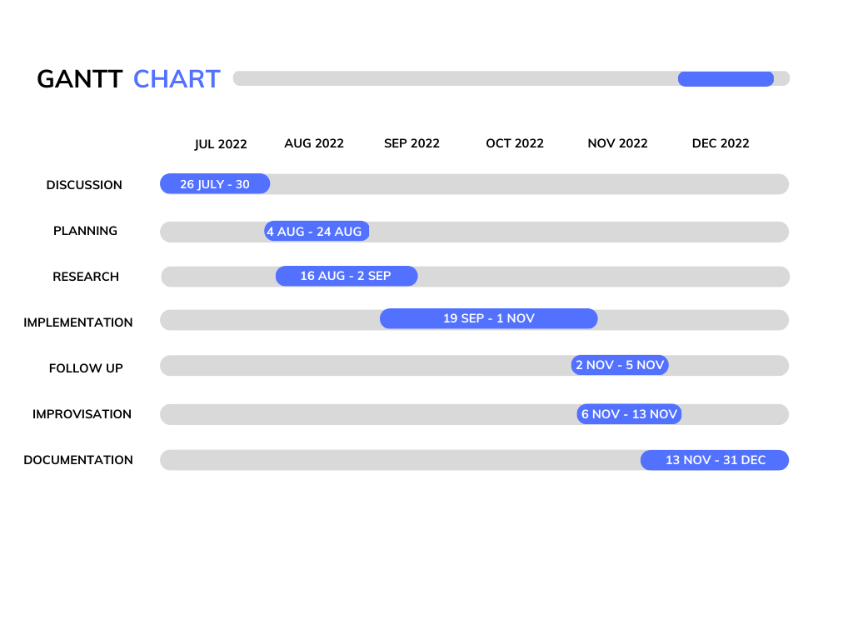

Fig. 1: Gannt chart for stage 1

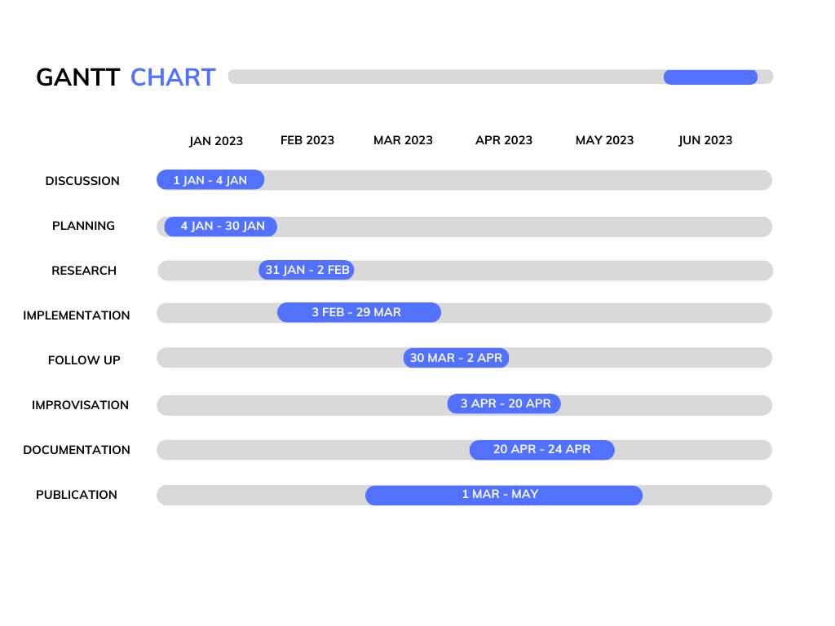

Fig. 2: Gannt chart for stage 2

**1.5 Organisation of the report**

The material presented in the project report is organised as follows. Chapter 1 consists of introduction, need of our project, scope and the project schedule which gives an overview of our entire model. Chapter 2 consists of the survey of existing systems, limitations of existing systems, our problem statement, and the objectives of the project. It describes the literature review which analyzes previous content and literature related to the research problem, Gamification for Autism, and reports findings from multiple research papers, compares the results, and summarises them. Chapter 3 presents the proposed system and the characteristics of the proposed system. It includes

various components or parts proposed and their functionalities. Chapter 4 contains project design details, the methodology used, the hardware and software details, and information about the system in terms of images or diagrams, including tools, methods used, and special features of our system. Chapter 5 depicts the experimentation and implementation results, and a discussion of the analysis of the project outcomes. Chapter 6 concludes the project report, also discussing the future scope of our project, followed by the citations and references of all research papers studied and analysed to collect information for the project.

**CHAPTER 2**

**LITERATURE SURVEY**

**2.1 Survey of Existing Systems**

This literature survey includes studying the research papers which review the existing systems made for various applications of Human Posture detection and its applications in different fields. The survey provides a brief description of the paper on its contents and findings.

[Chen](https://link.springer.com/article/10.1007/s11042-019-7294-0#auth-Chen-Xi) et. al. [1] propose multiple elements to precise the total material body, and divide the target into many separate halves, appreciating head, trunk and limbs, and divide and treat the individual coaching part classifier for the human body target of advanced human posture and partial occlusion. Secondly, this paper offers a way of restoring a three-dimensional motion posture of an individual's body from a monocular video sequence.

[Jheanel](https://ieeexplore.ieee.org/author/37085852966) et. al. [2] used gyroscope readings from some human spinal points (thoracic, thoraco-lumbar, and lumbar) via mobile devices attached at those points, this study developed models to detect proper/incorrect sitting postures. It also established human body frame relationships and proper sitting posture. The findings also revealed relationships between body frame and posture.

[Panini](https://ieeexplore.ieee.org/author/38201689800) et. al. [3] proposed a method for classifying human postures for indoor surveillance in domotic applications. The approach was initially inspired by Haritaoglou et al. (1998)'s previous work, which uses histogram projections to classify people's posture. The authors modify and improve the approach's generality by including a machine learning phase to generate probability maps. If the initial constraints are met, the approach is very robust and has a very short computational time, allowing it to be used to process live videos on standard platforms.

[Davide](https://ieeexplore.ieee.org/author/37392011700) et. al [4] performs a human activity and posture assessment with triaxial accelerometers which provides useful information about functional ability.While this evaluation may be expanded

to new duties like real-time remote worker surveillance and emergency operators intervening in difficult circumstances, current technical breakthroughs enable the development of smaller

wearable devices incorporated into clothing. The authors offer a method that uses real-time signal processing of information from a single wearable triaxial accelerometer to determine human posture and activity level.The algorithm is unaffected by sensor orientation in relation to the body.

Rui et. al.[5] describe a method for detecting and classifying human posture in an individual context, more specifically in a classroom setting. The posture can be divided into two categories:

"Confident/Not Confident," which is aimed at the teacher's posture evaluation, and "Interested/Not Interested," which is aimed at the students.

[Abdulhamit](https://www.sciencedirect.com/science/article/pii/S1877050919321258#!) et. al. [6] develop a HAR system based on the smartphone sensors’ data using Bagging and Adaboost ensemble classifiers. The experimental results for the HAR data have been evaluated after performing different data mining techniques. For each subject, the total classification accuracy, the F-measure, and the ROC area were calculated. Adaboost ensemble classifiers algorithm improved significantly the performance of smartphone-based HAR, combined with SVM, it reached 97.44% accuracy compared to the rest of the classifiers.

Yiwen et. al. [7] present an interactive computer vision system that is sufficiently modular to work with different sources of human pose estimates, i.e., estimates from deep or traditional models that interpret RGB or RGB-D camera input. The system is capable of customizing exercises, capturing exercise information, evaluating patient performance, providing therapeutic feedback to the patient and the therapist, checking the progress of the user over the course of the physical therapy, and supporting the patient throughout this period.

In the following table we have summarized the literature survey of the research papers we went through along with the limitations of the model.

Table 1: Literature review of research papers

|  |  |  |  |  |
| --- | --- | --- | --- | --- |
| **Sr. No** | **Title of paper** | **Year of paper** | **Technology used** | **Limitations** |
| 1 | Analysis of moving human body detection and recovery aided training in the background of multimedia technology | 2019 | It proposes multiple parts to express the whole human body, and then divides the target into several separate parts and treats the individual training part classifier for the human body target of complex human posture and partial occlusion. | This system only detects the several parts such as head, trunk, limbs etc but this system is incapable of correcting the posture. |
| 2 | Real-Time Human Sitting Posture Detection Using Mobile Devices | 2020 | A belt-shaped wearable gadget with a mechanism to identify the stressed area and the length of time a person has been sitting in the same position has been developed. | The challenges were how to get the information about every point on the back area or how to calculate the stress data. |
| 3 | A machine learning approach for human posture detection for indoor surveillance applications | 2019 | This study discusses a method for classifying human posture that has been developed for indoor surveillance applications. | The proposal lacks generality and is too tailored to manually set models. |
| 4 | A Real-Time and Self-Calibrating Algorithm Based on Triaxial Accelerometer Signals for the Detection of Human Posture and Activity | 2020 | This paper provides a  formula for  Human stance  and  activity-level  discovery, based  on the immediate  the processing of  signals generated  wearable by one  triaxial  accelerometer | Instead of detecting activities such as “walking,” “climbing stairs,” or “sitting,” the system should also provide a general estimation about the subject's activity level |
| 5 | Human Body Posture Detection in Context: The Case of Teaching and Learning Environments | 2019 | This work offers a method for identifying and categorising human posture in a personal setting, more specifically in a classroom setting. | It is not necessarily true that a speaker who is addressing an audience with "poor" posture is less certain or at ease. |
| 6 | Smartphone-Based Human Activity Recognition Using Bagging and Boosting | 2019 | The purpose of this paper is to develop a HAR system based on the smartphone sensors’ data using Bagging and Adaboost ensemble classifiers. | The proposed system is mostly used for elderly people and the disabled and the same can be difficult for them to use. |
| 7 | Home-based Physical Therapy with an Interactive Computer Vision System. | 2019 | The system is capable of customizing exercises, capturing exercise information, evaluating patient performance, providing therapeutic feedback to the patient and the therapist, and supporting the patient throughout the course of the physical therapy. | They could not develop an algorithm that gives more detailed feedback on how the patient is doing in the present state. |

**2.2 Limitations of Existing Systems**

After analysing multiple research papers and available applications based on Fitness Tracker for posture correction some common constant limitation features can be observed:

* The applications only depict sample workout videos
* Huge social media platforms like Youtube, Instagram and Facebook have content available that poses as a workout guide for users but it doesn’t help them realitime.
* Even if the application is working on realtime data, there is no audio feedback.
* Maybe visual feedback is demonstrated through colour change of the body points but it doesn’t help the user all the way.
* Most of the applications that provide huge number of features are not free of cost and charge huge amounts.

**2.3 Problem Statement**

The aim of this project is to build a Fitness tracker which will help to assist people perform these workouts independently at home and at their own pace. Our fitness tracker will ensure that the relevant exercises are done correctly with a proper posture. This will be carried out by real-time posture analysis during the exercise to provide audio visual feedback on improvement of form.

**2.4 Objectives**

* Identification of the human body parts with efficiency and accuracy is a crucial phase in our approach (pose).
* To aid individuals in performing certain exercises independently.
* Our fitness tracker attempts to provide feedback on any form corrections that are required when performing a certain workout.
* It offers support during a workout in the form of both auditory and visual feedback.
* The user's skeletal points are matched with the learnt model during real-time posture analysis.
* If the exercise is performed incorrectly, the voice assistant will provide feedback and the counting meter will not advance the repetition count, letting the user know that he or she made a mistake in the current repetition and may remedy the error in subsequent repetitions.

**CHAPTER 3**

**PROPOSED SYSTEM**

**3.1 Proposed System**

In the suggested system, we model the human body as a collection of limbs and examine the angle between limb pairs to find flaws and provide the user a course of corrective action. Based on a threshold deviation between the limb angles, we may very successfully identify and discover flaws in the user's activity (position). In order to assess and identify faults, we provide a system that can be utilized with any camera-based device capable of streaming the user workout.

Fig. 3: Flow chart of system

The system begins by obtaining the user's live view. The user then decides the workout he or she wishes to do. The user is then offered a guided video that demonstrates how the workout should be performed in order to familiarize them with the process. The user then begins their workout, which is then recorded on the screen. Now, a counter is available to indicate the user how many accurate repetitions there were during the workout. The voice assistant informs the user that the repetition was incorrect and that the number displayed on the screen does not represent the change for that specific repeat if they do the exercise improperly. The user will now be aware that they performed the exercise wrong and that they need to make the necessary corrections.

Utilizing voice assistant, the system recognises positions taken by the user and instructs them if they are performing the exercise correctly or not. The user is given a metre to utilise to track their workout repetitions. In order to be more engaging with the user, this procedure is carried out in real-time.

**3.2 Component and Functionality**

**OpenCV**

The vast open-source library known as OpenCV is used for computer vision, machine learning, and image processing. It currently plays a significant part in real-time operation, which is crucial in modern systems. Using it, one may analyze pictures and movies to find people, objects, and even human handwriting. Python is able to handle the OpenCV array structure for analysis when combined with a variety of modules, such as NumPy. We employ vector space and apply mathematical operations to these characteristics to identify visual patterns and their different features.

OpenCV's initial release was 1.0. OpenCV is free for both academic and commercial usage because it is distributed under a BSD license. It supports Windows, Linux, Mac OS, and provides interfaces in C++, C, Python, and Java.

Real-time applications for improved processing efficiency were the primary consideration when OpenCV was developed. Everything is written in C/C++ that has been optimized to take advantage of multi-core processing.

**MediaPipe**

We employ cutting-edge products and services powered by MediaPipe every day. MediaPipe needs fewer resources than resource-guzzling machine learning frameworks. Even embedded IoT devices are able to run it thanks to how small and effective it is. After its official debut in 2019, MediaPipe provided academics and developers with a whole new range of possibilities.

The MediaPipe Framework is used to create machine learning pipelines for processing time-series data, including audio, video, and other types. This cross-platform framework is compatible with embedded devices like the Raspberry Pi and Jetson Nano as well as desktop/server, Android, and iOS systems. It consists of the Solutions and the Framework. The Framework, which was created using C++, Java, and Obj-C, includes the following APIs.

The technique employs a two-step detector-tracker ML pipeline that has proven effective in our MediaPipe Hands and MediaPipe.

The method makes use of a two-step detector-tracker machine learning pipeline that has been successfully applied to our MediaPipe Hands and MediaPipe Face Mesh solutions. The pipeline begins by identifying the person/pose region-of-interest (ROI) in the frame using a detector. The tracker then uses the ROI-cropped frame as input to forecast the posture landmarks and segmentation mask within the ROI. It should be noted that the detector is only used in video use cases when necessary, such as for the initial frame and when the tracker was unable to detect the presence of a body position in the preceding frame. The pipeline simply calculates the ROI for other frames using the stance from the previous frame.

**NumPy**

To work with arrays, utilize the NumPy Python module. NumPy is the abbreviation for numerical Python. Additionally, it offers matrices, the Fourier transform, and linear algebra functions. It is an open source project, therefore using it is free. Lists are Python's version of arrays, however they take a long time to execute.

NumPy aims to provide array objects that are up to fifty times faster than typical Python lists. The ndarray NumPy array object provides a variety of supporting methods that make using ndarray quite straightforward. Arrays are frequently used in data research, where efficiency and resources are essential.

**Video capture in opencv**

Python has a variety of libraries for handling photos and videos. One of them is OpenCV. The OpenCV library, a sizable collection of tools for image and video processing, is useful. Using OpenCV, we can capture video from the camera. You can create a webcam video capture object with its help, which you may use to record videos and edit them as you see appropriate.

**Steps to capture a video:**

Use cv2.VideoCapture to get a video capture object for the camera (). While inside an unending while loop, read the frames using the read() method of the previously constructed object. The cv2.imshow() method may be used to view the movie's frames. The loop is broken the instant the user touches a certain key.

**Human pose Function**

The ability to determine a person's posture from a video or live stream is crucial in a number of applications, such as full-body gesture control, physical activity measurement, and sign language interpretation. For example, it may be used as the basis for applications in dance, yoga, and fitness. In augmented reality, it is important. Thirty three 3D landmarks on the whole human body are

inferred by the Media Pipe Attitude framework for high-fidelity body position tracking from RGB video frame input.

This methodology outperforms other cutting-edge approaches and achieves great results in real-time, while other cutting-edge approaches often rely on robust desktop environments for inferencing.

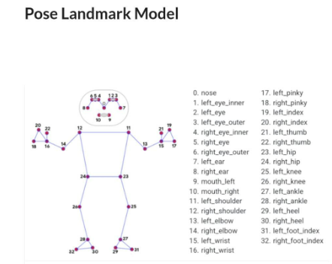

Fig. 4: Pose Landmarks

**CHAPTER 4**

**DESIGN AND METHODOLOGY**

**4.1 Design Details**

As Figure 4.2 shows us the DFD level 0 diagram of our project, its evident that the User has to select which exercise he/she wants to perform. Further a sample video occurs for reference. The user’s body points are captured in realtime and feedback is given accordingly. Since there is only 1 entity participating in the model, the user interacts with the model in the ways shown below.

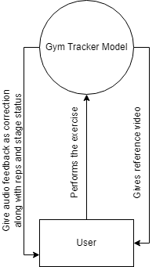

Fig. 5: DFD Level 0

After the exercise is complete the number of reps is displayed and the program exits. After every common mistake committed, the voice assistant plays a voice to let the user know that the pose is wrong.

Figure below shows the DFD for level 1. Here we have shown the model processes on a deeper level and how the user interacts with OpenCV. It also shows how the joint coordinates contribute.

Fig.6 : DFD Level 1

**4.2 Methodology**

In order to give the user remedial action and to fix faults, we model the human body as a collection of limbs and measure the angle between limb pairs. Based on a threshold deviation between the limb angles, we may very successfully identify and find defects in the user's activity (position) (position). In order to examine a nd identify flaws, we provide a system that can be applied with any camera-based device capable of streaming the user workout.

The system begins by acquiring the user's live view. The user then picks the workout he or she desires to complete. The user is then shown a guided video that teaches how to conduct the workout to acquaint them with how the program is to be done.

**4.3 Algorithm Implementation**

As we can see in the figure, we have created a function that takes the real time data points and calculates angle between the 3 points and returns the answer in radians.

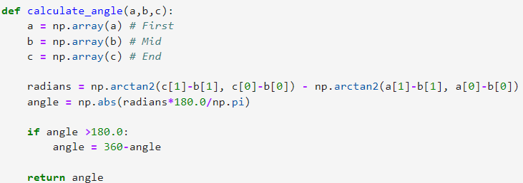

Fig.7: Algorithm code snippet

This function is used for multiple body points and returns values dynamically.Following is a sample code snippet for exercise ‘Bicep Curl’ showing conditional statements for correction and using calculate_angle function

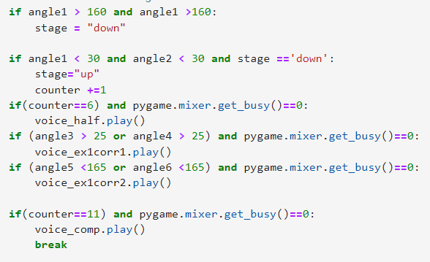

Fig, 8: Code snippet for conditional statements

**4.4 Details of hardware and software**

Operating system- Windows: 7 Service Pack 1+, 8, 10 (64-bit versions only)

Software used- Jupyter lab

CPU- SSE2 instruction set support.

GPU- Graphics card with DX10 (shader model 4.0) capabilities.

**CHAPTER 5**

**RESULTS AND DISCUSSION**

**5.1 Implementation**

1st exercise- bicep curl. Our model shows the user a reference video to follows along with a voice based instruction. Once the user has understood and referred to the video, they can press on Y to proceed.

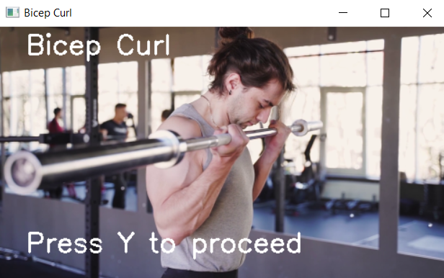

Fig. 9: Reference video for 1st exercise

User starts the exercise from rep 1. The counter shows the user the number of reps performed. Currently user is in stage ‘UP’ and further moves to stage ‘DOWN’.

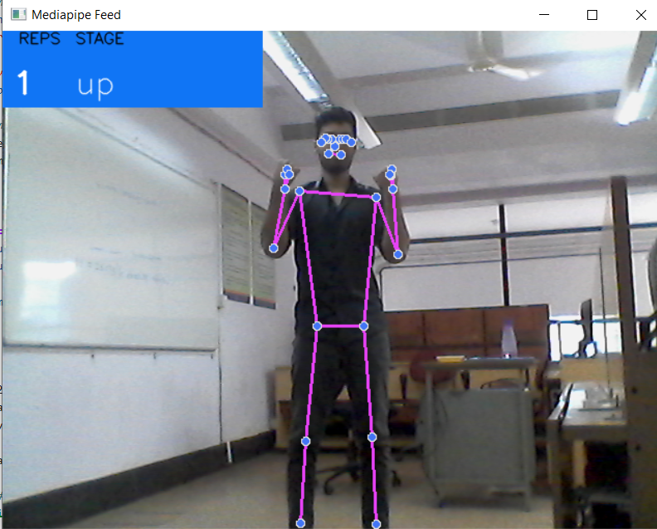

Fig. 10: user performing 1st exercise in up stage

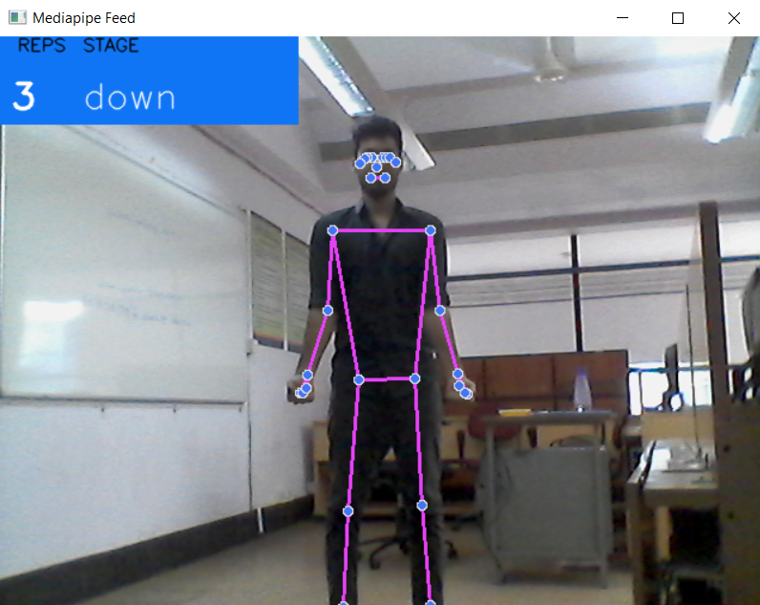

Fig. 11: User performing the exercise in down stage

2nd exercise- shoulder press. Our model shows the user a reference video to follow.

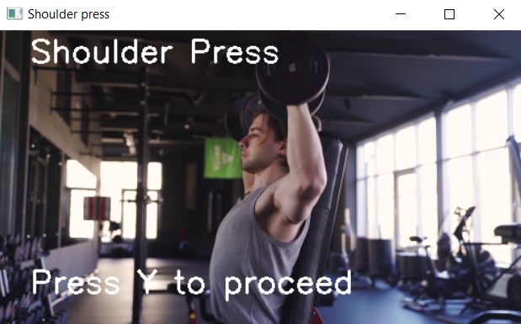

Fig. 12: Reference video for 2nd exercise

User starts the exercise from rep 1. The counter shows the user the number of reps performed. Currently the user is in stage ‘UP’ and further moves to stage ‘DOWN’

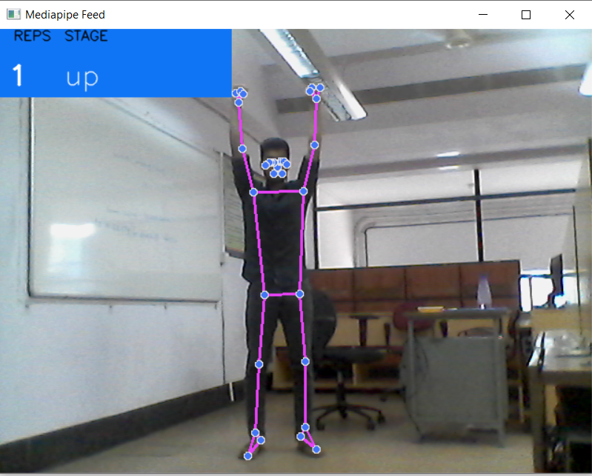

Fig. 13: user performing 2nd exercise in up stage

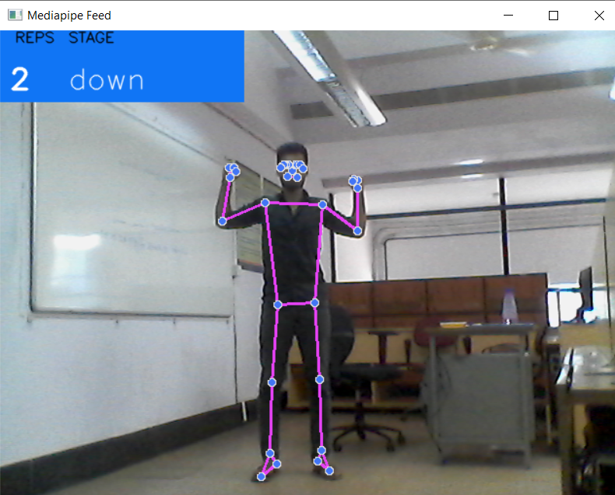

Fig. 14: user performing exercise in down stage.

**5.2 Testing**

Checking how MediaPipe collects photographs and videos in real time is the first step in system testing. The library's viability and compatibility with our hardware device were examined.

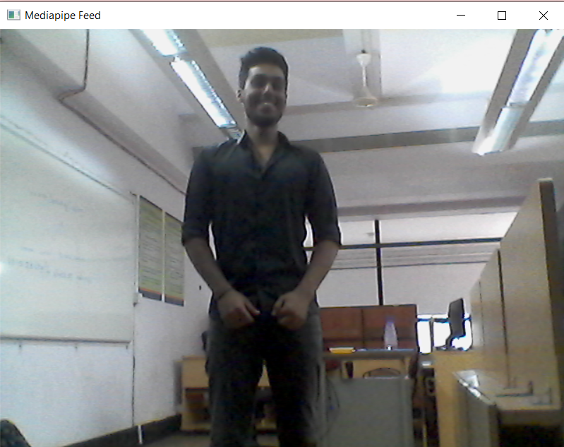

Fig. 15 checking mediapipe camera

After checking the visibility of mediapipe and OpenCV, the Pose_Landmarks function was tested to see how accurately the joint points of the user are being captured.

Figure 16: Pose Landmark function plots on the body

A function called calculate_angle was defined and tested. It takes 3 parameters that are the joint coordinates of the user and then displays the angle

Figure 17: Calculate_angle function working dynamically

**5.3 Results and discussion**

After analysing the results produced by our model, we have concluded that this has be expanded to further body movements and not just dynamic gym exercises. The accuracy measures can be refined further by tweaking the calculation function and increasing the body points captured in real time.

There are certain exercises which are a bit challenging for mediapipe to capture and so its difficult to apply the function and count the reps from it.

The voice assistant that has been integrated along with our model is working accurately but it may not show all possible corrections. It only focuses on common mistakes that maybe committed by users and provides audio feedback on the same.

**CHAPTER 6**

**CONCLUSION AND FUTURE SCOPE**

When using OurFitness Tracker, the workout will be examined to see whether or not the activity is being performed correctly. Additionally, it will keep track of the joint motions while the exercise is being performed and count the repetitions for the activity. To help the user improve their posture while executing the workout, a voice assistant will be added. In order to calculate the angle between the joint coordinates, which is used to assess the exercise's particular correctness, we have often employed functions. The user benefits greatly from the description of the exercise's stage of execution. Our concept is ideal for them because many individuals find it challenging to invest in specialized exercise facilities and frequently start out as novices. Our model is quite user-friendly for beginners and doesn't require a lot of technological expertise.

In order to correct the motions of the gym's patrons, this technology may also be included into the facility. In the future, physiotherapy may make use of this technology. Future upgrades to the device will allow doctors to use it to track patients' wound healing.

**REFERENCES**

[1] Chen Xi and Dongbo Shi, “Analysis of moving human body detection and recovery aided training in the background of multimedia technology”, Multimedia tools and applications, Springer Link, 2019.

[2] Estrada and Larry Vea, “Real-Time human sitting posture detection using mobile devices”, Region 10 Symposium, IEEE,2020.

[3] L. Panini and R. Cucchiara, “A machine learning approach for human posture detection in domotics application”, 12th International Conference on Image Processing and Analysis,IEEE, 2019.

[4] David Corone and Andrea Cristiani, “A Real-Time and Self-Calibrating Algorithm based on Accelerometer Signals for detection of human posture”,IEEE Transactions on Information Technology in BioMedicine, IEEE,2018.

[5] Rui Sacchetti, Tiago Teixeira, Bruno Barbosa, António J. R. Neves, “Human Body Posture Detection in Context: The Case of Teaching and Learning Environments ”, The Third International Conference on Advances in Signal, Image and Video Processing, SIGNAL 2018.

[6] Abdulhamit Subasi, “Smartphone-Based Human Activity Recognition Using Bagging and Boosting”, 16th International Learning and Technology Conference , Elsevier, 2019.

[7] Yiwen Gu and Shreya Pandit, ”Home-based Physical Therapy with an Interactive Computer Vision System”, International Conference on Computer Vision Workshops, IEEE, 2019.

[8] Amit Nagarkoti and Revant Teotia, “Realtime Indoor Workout Analysis Using Machine Learning & Computer Vision”, Annual International Conference of the IEEE Engineering in Medicine and Biology Society, IEEE, 2019.

[9] Hamid M Ali and Ali M. Muslim, “Human Activity Recognition using Smartphone and Smartwatch”,Fall CSCE Report Project, IJCERT, 2018.

[10] Durgesh Kumar, “An analytical study of use and effects of fitness trackers on humans”, International Multidisciplinary Conference on New Horizon in Business and Economics in the Light of the Digital World, Springer Link, 2019.

[11] Zakkoya H. Lewis, “The utility of wearing fitness trackers and implications”,10th Conference on Library of Medicine, NIH,2020.

[12] <https://www.youtube.com/watch?v=06TE_U21FK4>

[13] <https://www.youtube.com/watch?v=5kaX3ta398w&t=2568s>

**PLAGIARISM REPORT**

